ETHlogo

**Lecture with Computer Exercises:**

**Modelling and Simulating Social Systems with MATLAB**

Project Report

The empires are back: Who will win the currency wars?

Guillermo Fernando Valencia A

Zürich

June 24 2012

**Agreement for free-download**

We hereby agree to make our source code of this project freely available for download from the web pages of the SOMS chair. Furthermore, we assure that all source code is written by ourselves and is not violating any copyright restrictions.

|  |  |
| --- | --- |
| Guillermo F Valencia Arana |  |

# Table of content

# Abstract

# Philosophical View

# Main Stream Model

# Individual Contribution

# Game theory toolbox

# Simulations, results and discussion

# Summary and Outlook

# MATLAB code

# References

# Abstract

Using evolutionary game theory we found when countries apply tit-for tat strategies economical blocks "emerge". Based on the framework created by (Helbing, 2011) we model currency wars as a confrontation between two blocks with antagonistic currency systems. We find the key variables to understand when a new standard emerges and who will win the currency wars. The other possible scenario is the coexistence of two monetary systems with antagonistic interests. Finally, we model the distribution of firm size inside every block. We found that the size distribution follows power laws. The distribution is less skewed where there is coordination between blocks and is highly skewed when there is a prisoner’s dilemma or a coexistence scenario.

# Fundamental Questions

- Why trading blocks emerge?

- What are the possible equilibrums in the international trade between two blocks?

- Who will win the currency wars?

- How to design policies to prevent a currency war?

- How currency wars affects firms size distribution inside every block?

- In a currency war situation, do industries become more concentrated than in other possible international trade equilibriums?

- Are state capitalism and transnational companies correlated with a currency war scenario?

# Philosophical view

What is money? perhaps the easiest way to understand why money is so difficult to define is to think about the analogy of the blind man looking at an elephant. He can only describe it by using his hands. “Big ears, so must be big ” “Thin tail, so must be small” “Huge belly, so must be ferocious”. We need a multi-dimensional perspective to understand money and only if we do that we can aspire to get some impression of the complete picture.

Money in general is defined as a way to measure value, a unit of account, an instrument of exchange or as an instrument to store wealth. But has money any value by itself?

Aristotle said that money must have a high cost of production in order to allow it to represent a lot of value in a small physical format. He also said that money must be a **standard** accepted by every body as an instrument of exchange. Since then it is thought that only gold and silver could be accepted as money.

But why a coffee farmer in Colombia must exchange his production for something is essentially useless. Why there is value in digging a hole in mountain to extract something we will put in other kind of hole (bank vault)?

This Aristotelian view about money is very consistent with the Marxist view that goods only have value by the amount of labour used to produce them. But why in a world in which all values are subjective gold and silver are the only with an objective value. ?

Gold and Silver (money) have not value because of time, labour, technology and resources needed to produces it. Money has value only because every body believes it has some value.

Plato said money is just **social convention** and money must not have value by itself. But if money is a social convention this must be inside a social institution that ensures the existence of this convention. In modern times this social institution are the nations. Nations defined by Rennan are in some sense the **willingness of individuals to live together.** (<http://en.wikipedia.org/wiki/Ernest_Renan>).

“It is by money that individuals organize themselves economically and establishes legally the contracts that bind them”

For a nation to prosper it needs two instruments; the state and money. Both of them are necessary to protect the individual willingness of individuals to stay together. Nevertheless, money has a completely different nature than the state. Money is a common good. Every body must enjoy it. Money must not be owned by anybody especially not by the state.

The temptation of government to take control over money is so high. Taking control over money is easy to translate into political capital and finally power perpetuation. There are many episodes in history when government takes control over money supply. The debasement of Roman denarius, the debasement of the Spanish dollar, the episode of hyper-inflation in Germany after the first world war, the cascade of hyperinflation episodes in Latin-American economies in the 90s.

When money is controlled by the state, the population will not be better off. This statement is concomitant with our findings in model 3. We will show using our computational framework that the probability distribution of firm’s size has more skewness when government take control over money supply. (Currency War situation)

To avoid government to take control over money supply is perhaps one of the most ferocious battles in democracy across history. There are various ways to prevent the government to take control of money. 1) To create a political independent institution that controls the money supply (independent central banks). 2) To use a gold standard. 3) To abandon the national characteristics of money. The nation prefers to peg the currency to a more trustworthy currency.

Money is the nerve system of the Economy. It transmits signals about the competitive advantage of every country e.g. cheap labour, technology, military power (exchange rate) or signals about the trade off between consumption and savings citizens are facing in every country. (interest rate). When government use the visible hand take control of the money supply this signals are completely distorted generating miss-allocation in the whole market.

Currently, several rounds of Quantitative Easing by the Federal Reserve and other measures by its European counterparts started a competition of who is able to depreciate its currency more. Meanwhile, the Chinese Government has been accused of "unfair" devaluation of the Yuan claimed as an act of war by most developing countries such as Brazil and China. We are in the age of currencies wars.

# Main Stream fundamental of Currencies Wars

**IS-LM Model Approach**

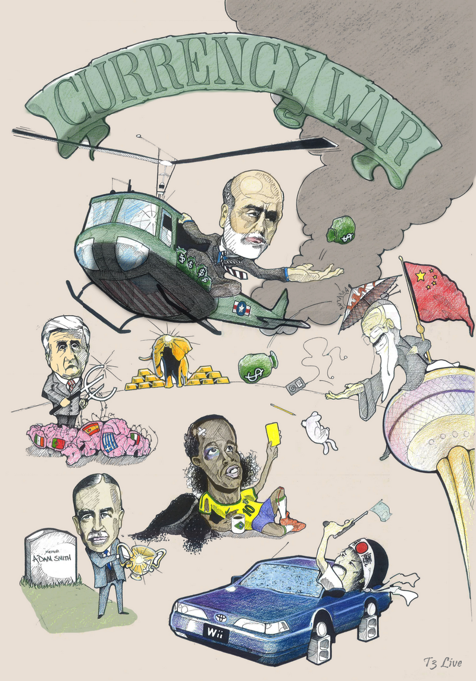Since the beginning of the capitalism international trade has been questioned. Exponents of the Laissez –Faire doctrine defend that free trade increases the world surplus thanks to increase in global specialization. Nevertheless, no country became a global power leader without an industrial policy that includes some strategic protectionism measures. Historically, currency wars appear when there is a technological change that modified the predominant socio-economical world order.

In this project we would like to present currencies beyond the concept of currencies as a medium of exchange, liquidity or value storage. Currencies reflect paradigms. They are associated with the dominant and the challenging cultures of the moment. Therefore, currency wars reflect a conflict between technological and socio-economical paradigms.

The mainstream model to understand the relationship between exchange rate and GDP is the Mundell-Fleming model. This model part from what Steven Keen will describe as the totem of macroeconomics; the cross that shows the simultaneous equilibrium between supply and demand in the money and goods market. This model describes two regimens, the flexible exchange rate and the fixed exchange rate regimen.

Because we want to model currency wars let’s assume there are two trading blocks. In particular developed markets (DM) and emerging markets (EM). Emerging markets have higher interest rates than developed markets because developed markets were in recession and policy makers decided to “stimulate” their economies. Developed markets have a flexible exchange rate and emerging markets has a fixed exchange rate.

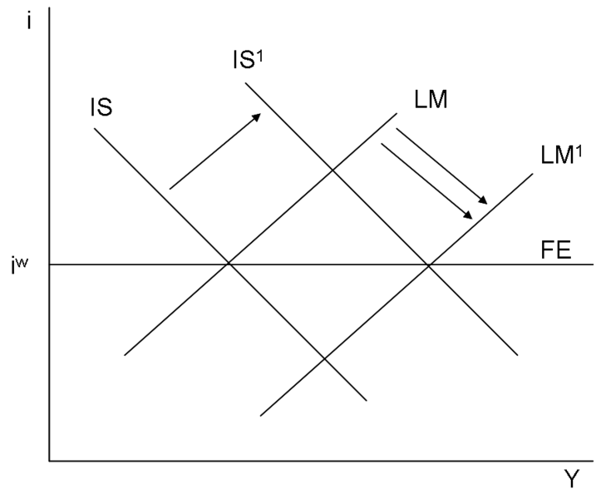

Figure 1 Increase in government spending in fixed exchange rate system <http://en.wikipedia.org/wiki/Mundell–Fleming_model>)

Following the logic of the Mundell-Fleming model the increase in monetary supply (quantitative easing QE) will move the liquidity preference curve (LM) to the right decreasing the DM interest rate. The decrease in the DM interest rate make investors prefer to bonds or other assets with higher returns in EM markets. This net capital outflow devaluates the DMs currency boosting their exports. The increase in exports shift the “Investment and Savings” (IS) curve to the right, generating an increase in the national income. So, following this logic an increase in monetary supply generates a temporal increase in GPD.

On the other hand, EM with a fixed exchange rate will increase their capital inflows attracted by higher interest rates. This new flow will generate a big pressure in the EM currencies. Central banks in EM will increase the amount of foreign reserves, generating an increase in the money supply. This increase in the money supply tends to equate EM to DM interest rates while increasing the EM GDP.

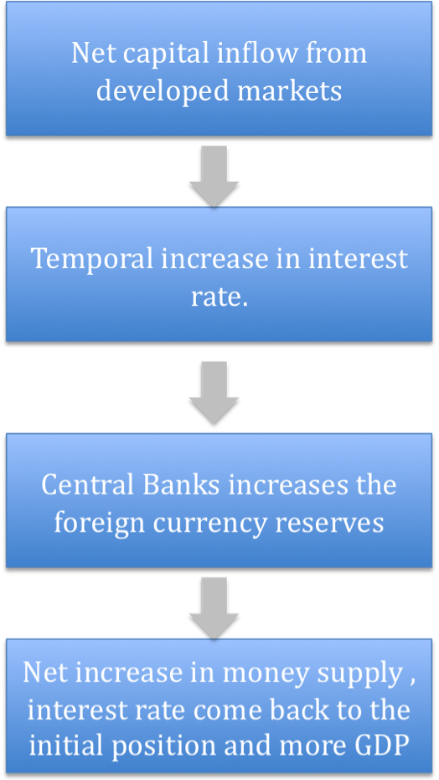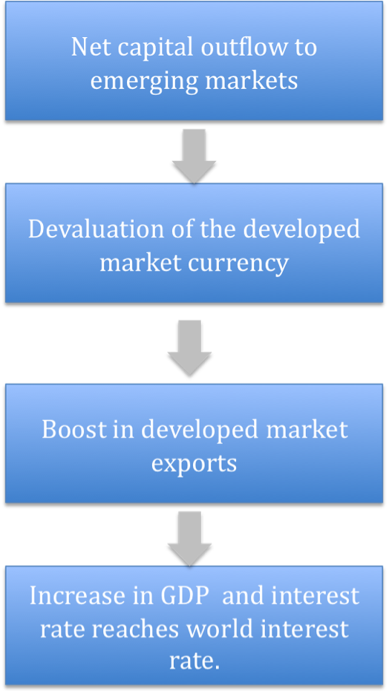

Figure 2 Emerging Market with fixed exchange rate

Figure 1 Developed market with monetary

supply stimulus with a flexible exchange rate.

Therefore, if Emerging Markets, let’s say China has a fixed exchange rate, the DM quantitative easing or any increase in the monetary supply will produce a low interest rate, but the DM currencies will be not depreciated against the Chinese Yuan. Therefore, there is no improvement in the exports and the increase in the monetary supply will not stimulate economic growth.

From the point of view of DM markets the EM markets are manipulating the currency prices. From the point of view of EM the developed markets are manipulating the currency by means on excessive money supply. That explains the antagonistic interests between these 2 blocks.

Under these circumstances EM will have more growth, because the increase in developed markets money supply is translated into an increase in the EM supply generating a very politically convenient boom in these economies.

There are also risks associated with this short- term boom in EM economies. The generation of inflation or asset bubbles in their economies. EM policy makers have a great temptation to take advantage of the short-term boom despite the negative punishment of having inflation or asset bubbles and for developed markets policy makers printing money means votes in the coming elections.

With that framework in mind, we can model those “trade battles” using game theory. We will use the generic games to model games between 2 actors with contradictory interests described in table 1. For instance, we will model 4 kinds of game depending on the payoff of the matrix. P=Punishment, S=Sucker Payoff, T=Temptation to defeat payoff, R= Reward.

|  |  |  |
| --- | --- | --- |
|  | EM | |
| DM | No Free Trade | Free Trade |
| No Free Trade | P,P | S,T |
| Free Trade | T,S | R,R |

Table 1 Game matrix of economical blocks with antagonistic interests

1. Prisoner’s dilemma: T>R>P>S
2. Hawk-Dove Game: T>R >S>P
3. Harmonic Game: R> T> S>P
4. Stag-Hunt Game: R>T>P>S

# Currency Wars Tool Box

# Currencywartoolbox.tiff

# Individual contributions

The contribution of this project is the application of different frameworks of evolutionary game theory to evaluate the possible outcomes of a currency war. The aim of this project is to understand the most important underlying mechanisms of trade among economical blocks with antagonistic interests.

In the first part of this report we want to develop a thinking framework that provides some insight to policy makers, institutional investor or other stakeholders in the currency wars. Policy makers could use our approach from the point of view of incentives design. While institutional investors and pension funds could use it as a multi-scenario “map” with only a few intuitive parameters with the potential to be translated in terms macro currency strategy. The focus of this multi-scenario “map” is to enable long-term investors to have a better risk management inside the “trade battle”.

We present three different models. The first one is the standard iterated prisoner dilemma (IPD). The second is a multigame model. The IPD shows that when countries use “Tit for Tat” strategies, trading blocks are created where emerging markets (CURRENCY CONTROLLERS) grow more than developed markets. (PRINTERS). The iterated prisoner dilemma is a first approach with many unrealistic assumptions. For example, why to restrict ourselves to a prisoner dilemma payoff schema? It also assumes that every pair of countries has the same military or political power and that is of course un-realisitc. Finally, it does not give any insight in terms of policies design and neither to connect the model with the empirical data.

The second model begins where the first one ends. Therefore, it assumes the existence of economical blocks with antagonistic interests. This model is based on the paper Cooperation, Norms and Revolution by Helbing and Johansson. (Helbing, 2011). We assume the existence of two sets of countries with two opposite interests. As we mention before we are interested in modelling developed markets and emerging markets trade. In particular, today what developed markets consider a free trade policy is not one for emerging markets and vice versa. The cooperative population inside every block grows according to the standard equation of dynamical replicators. (Cressman, 1995)

In this model countries could interact inside the same block or with countries of other blocks. We assume symmetrical 2X2 matrix allowing countries to face 4 different games: Prisoner’s dilemma, Harmonic game, Hawk –Dove game, and Stag Hunt game. Three control parameters are introduced: Coordination, Trust and Power. Coordination and trust determine the games payoff matrix and power captures the GDP differences or military power differences. (Weibull, 1995)

We also propose empirical proxies for these parameters:

• COORDINATION: short term interest rates discounting inflation.

• TRUST: Credit growth differential between the two blocks.

• POWER: GDP/GDPmax*GDP/Debt

This model shows the existence of four possibilities; all countries cooperate and accept the other block “trade norm” (Harmony Game), two trade norms could coexist (Hawk and dove game), Bi-stability between the “trade norm” (stag-hunt game) and finally a currency war where nobody agrees and there is no “trade norm”.

In the third model we use the results of the second as a density of cooperative countries in EM and the density of cooperative countries of DM. The objective of the model is to make the extension from blocks of countries to blocks of companies. In this section we are interested in studying the firm’s size probability distribution. We assume that firms have 2 sources of growth; one is to create economies of scale or scope, and the other is the integration with suppliers and customers. The last generates value by means of lean processes and innovation.

The combination of this process shows many interesting results. It is consistent with the stylized fact of the collective dynamic of firms where the size distribution is skewed and follows power laws or Gibrart dynamics. (Sornette, 2008)

We show that when currency blocks are facing a currency war, the size dynamic is mainly determined by the ability of the company to create economies of scale and scope. Size distribution of firms follows a power law (Sornette, 2008). A Gibrart firm's size distribution (http://en.wikipedia.org/wiki/Gibrat's_law) is a particular case when there is no cooperation inside the block. One of the critics to the Gibrart model is that it assumes companies’ growth rate as Gaussian and uncorrelated random noise. Therefore, it is difficult to grasp the connection between the Gibrart dynamic and the business cycle. Our model made explicit the connection between the size distribution of firms and trade among companies in different trade blocks.

According to the ETH regulation I would like to mention that this project is also part of project in the class of Didier Sornette in the chair of entrepreneurial risks in a framework for risk detection called Risikopedia[1]. This project is also is part of my master thesis.

# Description of the Model

**Model 1**

In the first model we will assume that currency wars resemble a prisoner dilemma game. Protectionism measures are a kind of defeat. Allowing international trade is a way of cooperation. International trade allows specialization among countries one of the drivers of economical growth. In this sense, when both countries allow international trade, they are better off.

Model 1 presents a prisoner’s dilemma tournament among 18 countries. A couple of countries meet to trade and apply one of the possible random strategies. We would like to study 3 scenarios:

1. Every country has a free trade bias (probability free trade =0.7).
2. Every country has a protectionist bias (probability free trade= 0.3)
3. Scenario based on macro-economical variables. (Table)

We assume would like to study the temporal evolution of pay off as well as the results afters “250” trading days as proxy to the evolution of the GDP.

The measures we consider as protectionism are: capital controls, fixed exchange rates, quotes, trade tariffs, negative interest rates, quantitative easing or any form of printing money. We will focus our attention in three characteristics the countries level of debt/GDP, real interest rates and if the country if highly dependent of commodities exports.

In general with the matlab code you could simulate other scenarios based in the follow strategies:

1.TotalProtectionism

2. Total Free Trade

3.Imitate the opponent past strategy (Tit for Tat)

4.If once currency control, always currency control (GRIM)

“Fool me once, blame on you Fool me twice, blame on me” Indian proverb

5.Free trade bias (probability free trade 0.7)

6. Protectionist bias (probability free trade 0.3)

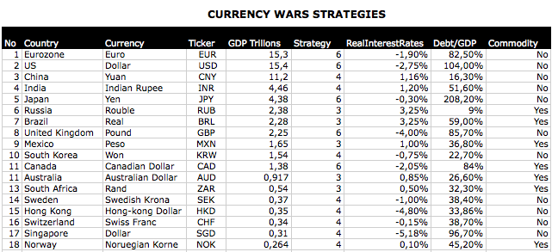

Table Scenario 3 based on key macro variables

**Model 2**

As we said before, the problem with this model 1 is that we assume explicitly that we are facing a game with T>R>P>S (Prisoner’s dilemma). Countries applying tit-for-tat strategies are able to improve the coordination and trust and to transform a multi-agent prisoner’s dilemma into antagonistic game between two economical blocks. This situation is completely different. We can’t assume explicitly that the two blocks are facing a prisoner’s dilemma anymore. Indeed, they can face any game of antagonistic interests such as Hawk-Dove game, Stag Hunt game, Harmonic game or a prisoner’s dilemma.

In Model 2 we want to understand what are the equilibriums on those games. We want also to determine if they are stable or not. We also focus on having a better understanding of the underlying mechanisms that make this antagonistic games to fluctuate between different equilibriums.

In other to understand those mechanisms we will analyze how POWER, TRUST AND COORDIANTION modify the system equilibrium. We reproduce the same results that (Helbing, 2011). We only change the names to have a more intuitive economical representation.

We assume the normal antagonistic game matrix between 2 players:

|  |  |  |
| --- | --- | --- |
|  | Player 2 | |
| Player 1 | Free Trade | No Free Trade |
| Free Trade | R,R | S,T |
| No Free trade | T,S | P,P |

**Definitions:**

**C**= R-T (Coordination)

**T**= S-P = (Trust)

**POWER** = f

1. Prisoner’s dilemma: T>R>P>S
2. Hawk-Dove Game: T>R >S>P
3. Harmonic Game: R> T> S>P
4. Stag-Hunt Game: R>T>P>S

When a country from one block has the same behaviour than a country of other block we called this action as coordinated action. If not, these countries are not cooperative. We are interesting in modelling the dynamic of the cooperative population in both economical blocks.

With this propose we use the general replicator equation described in (Cressman, 1995), this equation are in term of the game payoffs and the power difference between economical blocks.

(1)



(2)



**Model 3**

**This part of the project is the most important individual contribution of the project.**

The question here is about firm’s size. What is the size evolution of firms in every game? What is the most important growth factor in every scenario?

In reality every block are constituted by several firms. In this section we want to show how the different game scenarios of international trade affect the statistical dynamic of firm’s size.

We assume that firms can grow because of two reasons: Economies of scale and scope or by means of cooperation with other partners that leads to innovation and lean processes, we suppose partners are in the other economical block.

Economies of scale and scope are related with return on cost and financial leverage. Therefore this term is related with how much of their assets are invested in R&D, mergers and acquisitions or sales force. To develop economies of scale and scope, companies needs credit by means or issuing bonds or borrowing money from banks. Both of these alternatives depend directly on the firm size. For banks point of view more size more collateral. For debt issuing more size implies less risk perceived by the market and debt rating agencies.

The other source of economical growth is cooperation with suppliers and customers that lead to cooperative innovation and lean process. This depend of much of the assets are invested in joint ventures, integration with suppliers and customer, marketing etc.

In model 3 we use the population of cooperators (Q, P) in every block derived from model 2 as the density of cooperation in every economical block.

From a financial management point of view, we know that return on equity (ROE) of a company depends on 3 factors, return on sales (ROS), capital turn over (CT) and financial leverage (FL).

ROE= ROS*CT*FL.

We model that ROS and FL are related with company size by the reasons we explain above. While capital turnover are related with how much the companies is able to integrate with customers and supplier that n some way could be translated in term of lean processes and lean management.

 (3)

ROS*FL CT

Economies of Interaction with suppliers

Scale and Scope and customers

 (4)

Economies of Interaction with suppliers

Scale and Scope and customers

Where

 and no correlated.

P= Density of cooperative countries in developed markets

Q= Density of cooperative countries in emerging markets.

= Firm’s size in Developed Market Block



= Firm’s size in Emerging Market Block



N= Number of firms in Developed Markets

M=Number of firms in Emerging Markets

The intuition of the model is simple. If there is no-cooperation between blocks we assume that all the firms in every block are cooperative inside the block so the return is multiplicative by the numbers of firms inside the block. If there are cooperative with the other block, P and Q determines the density of cooperation in every block, so the multiplicative effect is  depending on the block.

# Model3.tiff

# Simulation Results and Discussion

**MODEL 1**

When countries have a free trade bias the total GDP is high and is distributed randomly around the 18 countries. In some way, every body wins. (Figure 1) When they have a protectionism bias they have a lower output and every body lose. (Figure 2)

When countries apply learning strategies like tit for that the system finds other solution. Trade blocks “emerges” (no in the complex system sense, it is natural consequence of the strategies used) from these strategies. In particular, commodities exporters find a way to cooperate with country with low of debt. This block will outperform countries with high levels of debt over GDP. (Figure 3)

This result is according with common economical blocks we observe in 2012, BRICS, DEVELOP MARKETS (DM). Inside BRICS (EM) are very different “animals” for instance China and India have very different productive processes than Brazil and Russia but given the scenario where DM always print money if EM countries apply tit-for-tat strategies BRICS countries find a path for coordination. This changes the bargaining power of the BRICS as a block and could transform the prisoner’s dilemma in a Stag-Hunt game or Haw and Dove game.

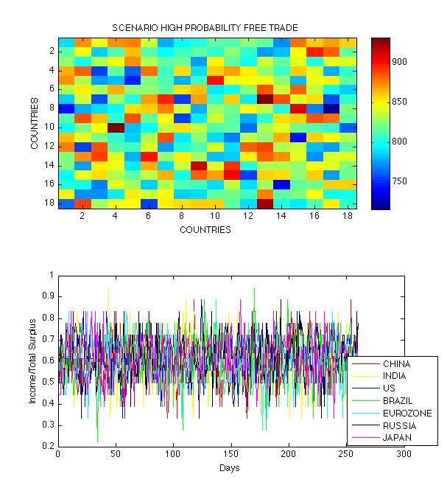

Figure Countries playing an iterated prisoner's dilemma with a free trade bias (cooperative bias)

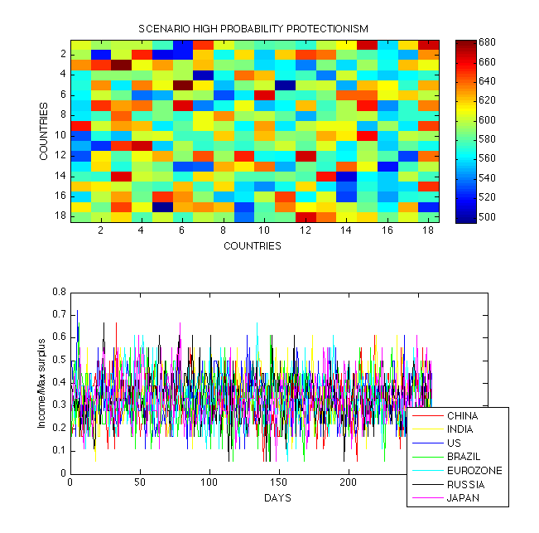

Figure Countries playing an iterated prisoner's dilemma with a protectionism bias (Defeat Bias)

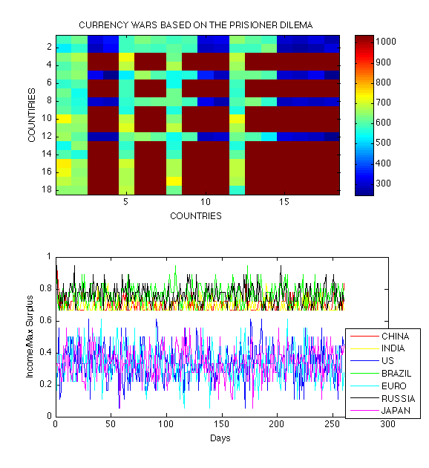

Figure Emergence of blocks using tit for tat strategies

There are 4 videos attached to the presentation were we can observe the different equilibriums in particular for the Hawk and Dove and the Stag-Hunt game .We show how the Nash equilibrium changes in both games depending on the values of trust an confidence and power differentials.

The harmonic game exist a trading norm and one of the behaviour predominate over the others.

**MODEL 2**

In this model we replicate the results obtained by (Helbing, 2011). We present 4 different antagonistic games and we are interested in identify the possible equilibrium and their stability.

There are 5 kinds of equilibrium, the combination:

1. P=1,Q=1 Emergence of a trade standard
2. P=1,Q=0 Emerging Markets win, its trading norm is dominant.
3. P=0, Q=1Developed Markets win its trading norm is dominant.
4. P=0, Q=0 Currency war no body wins, no body cooperates.
5. P=a, Q=b Coexistence of international trade system.

The 5th equilibrium is very interesting in the sense it allows the 2 different trade systems to coexist. This equilibrium is present in 2 games. The stag-hunt game where the equilibrium is unstable and the hawk-dove game when the coexistence state is stable.

**HAWK-DOVE GAME**

It is scenario with high trust but difficult coordination. This game has three Nash equilibriums but the only evolutionary stable is the coexistence state. We show in our simulation of the vector field around the equilibrium. (Figure 4) (CURRENCY WARS HAWK-DOVE Variable Power.avi)

**Conclusion: Difference in power in a scenario of trust but difficult coordination will generate a currency war. (**In the video is clear the influence of the power differential**)**

**STAG-HUNT GAME**

In the Stag and Hunt scenario incentives are aligned R-T>0, therefore it is possible to have a coordinated action. The problem here is that there is no trust S-P<=0 .In this game exists 3 Nash equilibriums one of currency system is accepted by the other block. The co-existence is an unstable equilibrium in this game. In this scenario difference in power generates a currency system that both blocks accepts. (Figure 4)

**Conclusion: In a scenario of easy coordination but no trust, power differences will create a dominant currency system.** (CURRENCY WARS STAG-HUNT Variable Power.avi)

**PRISONER’S DILEMMA**

It is a scenario where there is no trust and coordination is difficult. The game converges to a no cooperation state Q=0, P=0 (Figure 4)

**HARMONIC GAME**

It is a scenario where there is trust and coordination. The game converges to a no cooperation the emergence of a standard or international trade norm Q=1, P=1. (Figure 4)

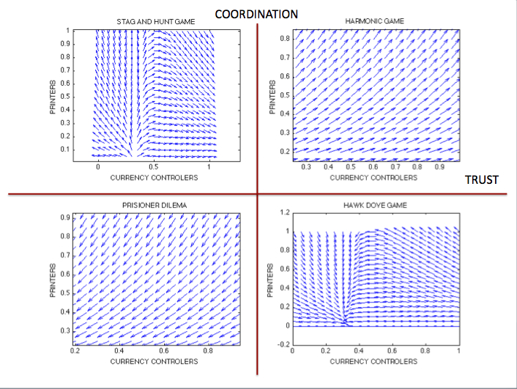

Figure Currency wars possible antagonic games, attractors and repulsors.

**MODEL 3**

In this model we are interested in understand the dynamic of firms the dynamic possible equilibriums.

**PRISONER’S DILEMMA**

Economical blocks are facing a prisoner’s dilemma scenario there are no cooperative countries in any block. Q=0, P=0

So rewriting equation (3) and (4) we will have:

 (5)

If n and m are large enough this equation converges to a power law of exponent of maximum likelihood =2,019.

**Case 2** **Stag-Hunt Game (Bi-stability)**

a) If P=0 and Q=1, the emerging markets firm’s size follows a power law exponent close to one, and the developed markets a power with exponent of maximum likelihood of 1.9161.

 (6)

b) If P=1 and Q=0, the emerging markets firm’s size follows a power law exponent close to 2 and the developed markets a power with exponent of maximum likelihood of 1.9161.

 (7)

**Case 3 Hawk-Dove Game (Coexistence)**

If P=a and Q=b our equation have the follow form:

 (8)

In this game has 3 equilibriums, 2 in pure strategies and one in mixed strategies, the only evolutionary stable equilibrium is the coexistence case for P=0,5 and Q= 0.4 we get a power law with exponent with maximum likelihood =2.1702

**Case 4 Harmonic Game (Emergence of a norm)**

If P=1 and Q=1 the size equation have the following form:

** (9)**

The size distribution follows a power law and the coefficient of maximum likelihood is 1,5158

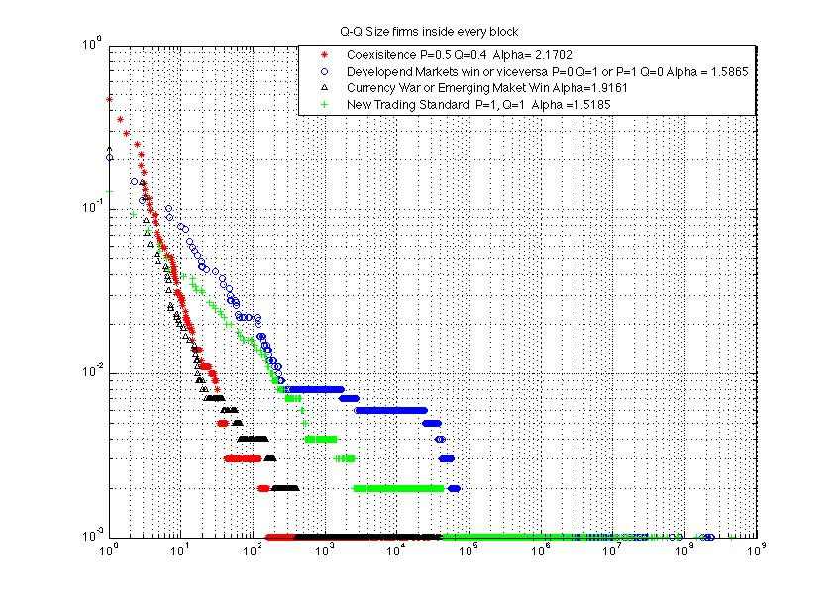

Figure Power law distribution in the different equilibrium. Alpha calculation based on the Kolmogorov test using http://www.santafe.edu/~aaronc/powerlaws/ (Santa Fe Insitute)

# Summary and Outlook

In this project we find that countries that are facing an antagonistic games converges to two currency blocks when they apply tit-for-tat strategies.

The second step was to find the equilibrium states of the games that resemble a confrontation of two blocks with antagonistic interests. We found 5 possible equilibriums both blocks win, one of them wins, all lose, or both coexist. The equilibrium’s convergence depends on the level of trust and coordination. In a situation where coordination is possible but there is no trust the coexistence state is unstable. On the other hand, in situations when there is trust but coordination is difficult coexistence is stable.

In the final part we prove that in the currency war state and coexistence states the asymmetry in firm size is higher than in the other states. It shows that no free trade measures tend to form oligopolies or national champions in the protectionist blocks. Firm’s size probability distribution follows different power laws depending on the equilibrium.

For future research I am interested in link this model with empirical macro-economical data. It would be also interesting to model what happen if the society in every block is also polarized and how it modifies the firm’s size distribution.

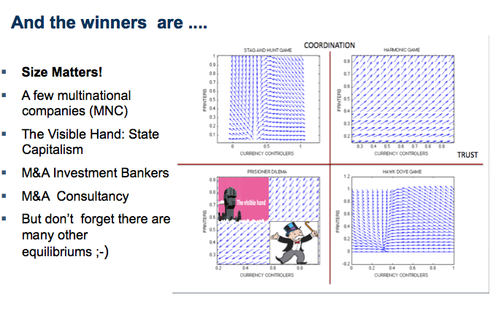

# MATLAB FUNCTIONS

Iterated currencies war functions:

%% Runs an ICW (Iterated Curency war)

% Countries with different strategies iteratedtly face each others and decide

% to be proteccionist or having free trade policies.

% Strategies have menory and based in the past behavior

printf('\nStart the tournament...\n');

R=200; % number of trading days

%% PLAYERS & STRATEGIES

% Set up 4 players and assign them different strategies

% 1 always proteccionism

% 2 always free trade

% 3 Currency control of the other do the same

% 4 GRIM if once currency control always currency control

% 5 Random 0.5 Proteccionsim

% 6 Random 0.7 Proteccionsim

Q=[1,2,3,4,5,6];

n=length(Q);

%% MATRIX PAYOFF

% We assume the payoff the total surplus of free trade, is

% higher than tempation to proteccionism 3+3 > 5+0

bothProteccionsit = 1;

bothFreeTrade = 3;

temptationToproteccionism = 5;

ProteccionistPayoff = 0;

payoffMatrix = [bothProteccionsit,Proteccionsit;

temptationToProteccionsit,bothFreetrade]

%% START CURRENCY WAR

%

Z=zeros(n,n); % Currency war table

for i=1:n

for j=1:n

[hC1,hC2,GDPC1,GDPC2 ]=iteratedcw(R,Q(i),Q(j),payoffMatrix);

Z(i,j)=scoreGDPC1;

end

end

%% PRINT RESULTS

%

display(Z);

scores = zeros(n,1);

for i=1:n

scores(i)=sum(Z(i,1:n));

end

display(scores);

imagesc(Z);

% Who wins?

% Why?

**Auxiliary Functions**

function x=trade(player,opp,strategy)

if (strategy == 1) %always protectionism

x=0;

elseif (strategy == 2) %always free trade

x=1;

elseif(strategy==3) %Currency control for Currency control (titfortat)

if(isempty(opp))

x=1; % Be nice first

else

x=opp(length(opp)); % Repeat last opponent's trade

end

elseif(strategy==4) %GRIM

threshold=0.9;

s1=rand(1,1);

if(isempty(opp)) && s1<threshold % Be nice first randomly probability 0.9

x=1;

elseif (isempty(opp)) && s1>=threshold

x=1;

else

if(sum(opp)<length(opp)) && s1<threshold % After one protectionism,protectionism

% always with probability

% 0.95

x=0;

else

x=1;

end

end

else % random free trader , and protecctionist trader

s=rand(1,1);

if (strategy==5)

threshold = 0.35;

else

threshold = 0.65;

end

if(s<threshold)

x=0;

else

x=1;

end

end

%% Itereaded currency war based on prisioner dilema

% Returns four arguments: the two lists of strategies (0= Protectionism, 1= Free Trade)

% and the two GDPs and the acumualated GDP.

function [X,Y,XGDP,YGDP]=iteratedcw(r,c1strat,c2strat,payoff)

% Init

mProtectionism=payoff(1,1);

mFreeTrade=payoff(2,2);

protecctionistlose=payoff(1,2);

protectionismwin=payoff(2,1);

X=[];

Y=[];

XGDP=0;

YGDP=0;

AcumXGDP=[];

AcumYGDP=[];

for i=1:r

% Determine the next move based on the trading story

newX=trade(X,Y,c1strat);

newY=trade(Y,X,c2strat);

% Add the last trade

X=[X,newX];

Y=[Y,newY];

% Update the GDP

if (newX==0) %Country1 protectionism

if(newY==0)

XGDP=XGDP+mProtectionism;

YGDP=YGDP+mProtectionism;

else

XGDP=XGDP+protectionismwin;

YGDP=YGDP+protecctionistlose;

end

else % Country1 Free Trade

if(newY==0)

XGDP=XGDP+protecctionistlose;

YGDP=YGDP+protectionismwin;

else

XGDP=XGDP+mFreeTrade;

YGDP=YGDP+mFreeTrade;

end

end

end

end

**POWER LAW SIMULATIONS**

%%POWER LAW SIMULATIONS

%% Equilibrium P=0.2,Q=0.3 COEXISITENCE EQUILIBRIUM or Bistability

P=0.4;

Q=0.5;

M=1000; % Number of firms in emerging markets block

N=1000; % Number of firms in Developed markets block

X=10*ones(1000,1000);

for i=2:1000;

for j=2 :1000

X(i,j)= ((1+0.0001*randn(1,1))^((1-P)*N))*((1+0.0001*randn(1,1))^(P*M))*((1+0.0001*randn(1,1))^(Q*N))*X(i-1,j);

end

end

%%% Equilibrium P=0, Q=1 (Develop markets dominates)

P=0;

Q=1;

M=1000; % Number of firms in emerging markets block

N=1000; % Number of firms in Developed markets block

X2=10*ones(1000,1000);

for i=2:1000;

for j=2 :1000

X2(i,j)= (1+0.0001*randn(1,1))^((1-P)*N)*((1+0.0001*randn(1,1))^(Q*M))*X2(i-1,j);

end

end

% Equilibrium P=1, Q=0 (Emerging Markets dominates)

P=1;

Q=0;

M=1000; % Number of firms in emerging markets block

N=1000; % Number of firms in Developed markets block

X3=10*ones(1000,1000);

for i=2:1000;

for j=2 :1000

X3(i,j)= ((1+0.0001*randn(1,1))^(P*N))*X3(i-1,j);

end

end

% Equilibrium P=0 , Q=0; (Currency War)

P=0;

Q=0;

M=1000; % Number of firms in emerging markets block

N=1000; % Number of firms in Developed markets block

X4=10*ones(1000,1000);

for i=2:1000;

for j=2 :1000

X4(i,j)= (1+0.0001*randn(1,1))^((1-P)*N)*X4(i-1,j);

end

end

%%% Equilibrium P=1, Q=1; (Emergence of international trade standard)

P=1;

Q=1;

M=1000; % Number of firms in emerging markets block

N=1000; % Number of firms in Developed markets block

X5=10*ones(1000,1000);

for i=2:1000;

for j=2 :1000

X5(i,j)= ((1+0.0001*randn(1,1))^(P*N))*((1+0.0001*randn(1,1))^(Q*M))*X5(i-1,j);

end

end

%%%%% Ploting

loglog(sort(X(500,:)/min(X(500,:)),2),sort(1-(cumsum(hist(X(500,:),1000)))/1000,1),'*r')

hold on;

loglog(sort(X2(500,:)/min(X2(500,:)),2),sort(1-(cumsum(hist(X2(500,:),1000)))/1000,1),'ob')

loglog(sort(X3(500,:)/min(X3(500,:)),2),sort(1-(cumsum(hist(X3(500,:),1000)))/1000,1),'^k')

loglog(sort(X5(500,:)/min(X5(500,:)),2),sort(1-(cumsum(hist(X5(500,:),1000)))/1000,1),'+g')

%%%% Calculate Alpha

[alpha, xmin, L]= plfit(X3(500,:))

**VIDEOS CODE:**

%%%%% Video Hawk-Dove Dynamic

C=[-0.2:-0.05:-4];

T=[0.1:0.05:5];

N=length(C);

% Get the handle of the figure

h= figure();

%%%%% STANG AND HUNT CHANGE IN POWER (F) C=3 T=-2

C=3;

T=-2;

F=0.1:0.01:0.9;

N=length(F);

% Get the handle of the figure

h= figure();

% Prepare the new file.

aviobj= avifile('CURRENCY WARS STAG-HUNT Power Variable.avi');

for i=1:N;

z=10*ones(21,21);

[x,y]=meshgrid(0:.05:1,0:.05:1);

dy = y*(1-y)*(T*F(i)+(C-T)*F(i)*y+C*(1-F(i))+(T-C)*(1-F(i))*x);

dx = x*(1-x)*(T*(1-F(i))+ C*F(i)+(C-T)*(1-F(i))*x+(T-C)*F(i)*y);

dyu = dy./sqrt(dx.^2+dy.^2);

dxu = dx./sqrt(dx.^2+dy.^2);

imagesc(0:.05:1,0:.05:1,z)

colormap(gray)

hold on;

quiver(x,y,dxu,dyu)

hold off;

title(['STAG AND HUNT T= -2',' C=3 ',' F= ',num2str(F(i))])

ylabel('PROPORTION OF COOPERTIVE PRINTERS ')

xlabel('PROPORTION OF COOPERATIVE CURRENCY CONTROLERS')

Frame = getframe(h);

aviobj = addframe(aviobj,Frame);

end

close(h)

aviobj = close(aviobj);

# References

Cressman, R. (1995). Evolutionary game theory with two groups of individuals games an economic behavior. *11*, 237-253.

Helbing, J. (2011). Cooperation, Norm and Revolutions : A unified game-theoretical approach. *PlosOne* .

Santa Fe Insitute. (s.f.). *Power Laws*. Obtenido de http://www.santafe.edu/~aaronc/powerlaws/

Sornette, S. M. (August de 2008). Theory of Zipf's Law and General Power Distributions with gibrart law of proportional growth.

Weibull, J. (1995). *Evolutionary Game Theory.* Cambridge, MA: MIT press.

Wikipedia. (s.f.). *Kontratiev Wave*. Obtenido de http://en.wikipedia.org/wiki/Kondratiev_wave

Wikipedia. (s.f.). *Mundell Fleming Model*. Obtenido de http://en.wikipedia.org/wiki/Mundell–Fleming_model

1. http://risikopedia.ethz.ch/ER/wiki/index.php/The_empire_strikes_back:_how_to_win_the_currency_wars